CSE 3009: Internet of Things (IoT)

Project Report

On

**Door Latch Control Using IOT Face Recognition**

By

|  |  |
| --- | --- |
| G Sai Tharun Kumar | 19BCE2235 |
| Ch Anirudh Sai | 19BCE0046 |
| T Ruthvik Reddy | 19BCE2238 |
| A Veerendranath | 19BCEI0238 |

Slot : B2

Under the Guidance of

**Dr. Vishnu Srinivasa Murthy Y**

School of Computer Science and Engineering

Vellore Institute of Technology (VIT)

Vellore, Tamilnadu – 632014

December 2021

**CERTIFICATE**

This is to certify that A.VEERENDRA NATH(19BCI0238) 3rd year B.Tech (Computer Science & Engineering) from Vellore Institute of Technology (VIT) has successfully completed his project work in the field of Internet of Things (IoT) on the topic Home Automation. This is a record of his/her own work carried out during the Fall Semester of the Academic Year 2020-21under the guidance of Dr. Vishnu Srinivasa Murthy Yarlagadda. He has presented his project in the presence of faculty.

Dr. Vishnu Srinivasa Murthy Y

Assistant Professor / Guide

**ABSTRACT**

In today’s modern world, it gets difficult to maintain trivial things from a day-to-day basis, a key for a door lock is one such example. We have all lost some or the other key in our lifetimes and surely not just once! To overcome such a hassle, we came up with an automatic door latching system that unlocks only when the owner/admins face is scanned by the 4x3 cm ESP32-camera onboard of the locking system.

This IOT based system not only overcomes the need to carry a key for your door, but also notifies the owner if someone else tries unlocking the door by scanning his/her face. The alert can be triggered in form of sound alarm or sending a message alert to the owner. This concept has a large scope of expansion and can be widely applied to many industries where the user requires some kind of lock and key mechanism. For example, motor vehicles like cars and bike, safe unlock, suitcase/travel bag locks and much more. In this proposed system the door latch can be controlled using the esp-32 cam face recognition.

**ACKNOWLEDGEMENT**

The success and final outcome of this project required a lot of guidance and assistance from many people and I am extremely privileged to have got this all along the completion of my project. All that I have done is only due to such supervision and assistance and I would not forget to thank them.

First and foremost, I owe my deep gratitude to our IoT professor Dr. Vishnu Srinivasa Murthy Y, who took keen interest on our project work and guided us all along, till the completion of our project work by providing all the necessary information for developing a good system. I will also not forget to mention my group participants and also friends for the viable information which they provided to me during the course of this project which ultimately lead to amelioration of this project.

Last but not the least, I would also like to thank VIT University, and lectures with the help of which I was able to grasp knowledge for making this project. Also, I would like to thank my classmates and friends who helped me complete this project in such a short time.

G Sai Tharun Kumar

19BCE2235

December 2021

**CONTENTS**

Certificate 2

Abstract 3

Acknowledgements 4

1. Motivation 5

2. Problem Statement 6

3. Proposed Approach and Connection Specifications 7

4. Results Obtained 13

5. Conclusions 15

6. References 16

**List of Figures**

Figure 1: Esp-32 cam 8

Figure 2: Arduino uno 9

Figure 3: Relay module 9

Figure 4: Solenoid lock 10

Figure 5: Circuit diagram to demonstrate voltage separation 10

Figure 6: Table to show Arduino and Esp32 connections 11

Figure 7: Circuit diagram of Arduino and Esp32 cam 11

Figure 8: Hardware Connections 12

Fig 9: Interface of Application 13

Fig 10: Enrolling Faces in application 13

Fig 11: Capturing face to unlock 14

Fig 12: Solenoid lock opened after Face detection 14

**MOTIVATION**

The main motivation of this project is to provide authentication and also to automate the door unlock process by removing the burden of maintaining a physical key, the authentication inclusion helps in strengthening the home security system and can hence prevent unauthorized entries in to our home.

Security is at most concern for anyone nowadays, whether it's data security or security of their own home. With the advancement of technology and the increasing use of IoT, digital door locks have become very common these days. Digital lock doesn’t require any physical key but it uses RFID, fingerprint, Face ID, pin, passwords, etc. to control the door lock.

The most important of feature of any such home security system is to detect the people who enter or leave the house. Instead of monitoring that through passwords or pins unique faces can be made use of as they are one’s biometric trait. These are innate and cannot be modified or stolen easily. The level of security can be raised by using face detection. The proposed face recognition door lock security system has been developed to prevent robbery in highly secure areas like home environment with lesser power consumption and more reliable standalone security device for both Intruder detection and for door security.

**PROBLEM STATEMENT AND APPLICATIONS**

The major drawbacks in a common door lock are that anyone can open a conventional door lock by duplicating or stealing the key and its simply impossible if we want our friends and family to enter our house, without being actually present over there and also to maintain the key physically can create a problem losing the key. Thus, to eliminate this major issue we will be designing this smart door lock. The purpose is to find a face in the database, which has the highest similarity with the face in front of the camera face. Hence to tackle this problem we created a Face Recognition-based Door Lock System with a Relay module and Solenoid Lock using a ESP-32 The AI-Thinker ESP32 CAM module is a low-cost development board with a micro-SD card port and a small OV2640 camera. It contains a built-in Wi-Fi and Bluetooth chip, as well as two high-performance 32-bit LX6 CPUs and a 7-stage pipeline architecture.

The proposed face recognition door lock security system has been developed to increase home security with less power consumption and also to make it more reliable in standalone security device. This concept has a large scope of expansion and can be widely applied to many industries where the user requires some kind of lock and key mechanism For example, motor vehicles like cars and bike, safe unlock and much more.one more important application is, it can be very beneficiary for the visually impaired people

**PROPOSED APPROACH AND CONNECTION SPECIFICATIONS**

In this ESP32CAM door latch control project, we have made the ESP32CAM Face Recognition Door Lock System. One can add multiple faces in the esp32cam face detection automatic door lock. If it detects any enrolled face, the door will unlock automatically.

The major hardware components used are:

**1. ESP32-CAM board**

The ESP32-CAM is a small size, low power consumption camera module based on ESP32. It comes with an OV2640 camera and provides onboard TF card slot. It is inexpensive and easy to use. It allows creating IP camera projects for video streaming with different resolutions. ESP32-CAM has built-in PCB antenna.

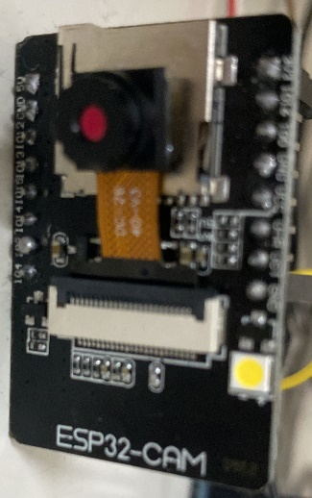

Fig 1: Esp-32 cam

**2. Arduino Uno board**

Arduino Uno is a microcontroller board based on the ATmega328P. It has 14 digital input/output pins (of which 6 can be used as PWM outputs), 6 Analog inputs, a 16 MHz quartz crystal, a USB connection, a power jack, an ICSP header and a reset button. It contains everything needed to support the microcontroller; simply connect it to a computer with a USB cable or power it with AC-to-DC adapter or battery to get started.

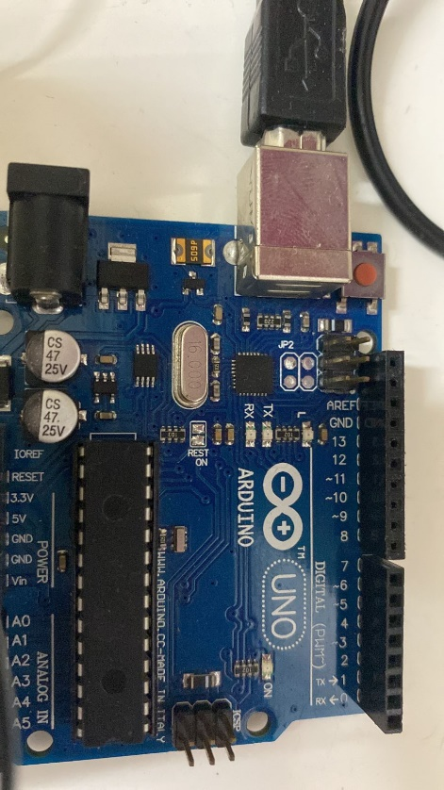

Fig 2: Arduino Uno

**3. Relay module**

The relay module is an electrically operated switch that allows you to turn on or off a circuit using voltage and/or current much higher than a microcontroller could handle. ... The relay protects each circuit from each other. Each channel in the module has three connections named NC, COM, and NO.

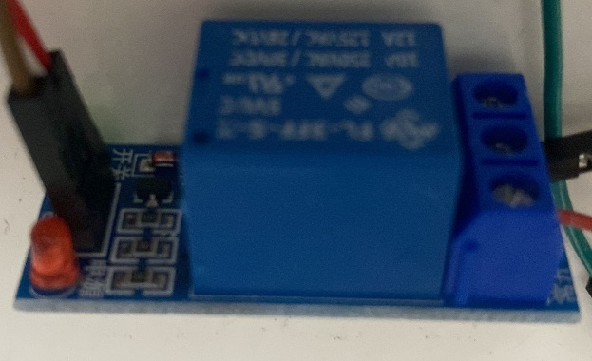

Fig 3 : Relay module

**4. Solenoid lock**

A solenoid lock works on the electronic-mechanical locking mechanism. This type of lock has a slug with a slanted cut and a good mounting bracket. When the power is applied, DC creates a magnetic field that moves the slug inside and keeps the door in the unlocked position. The slug will retain its position until the power is removed. When the power is disconnected, the slug moves outside and locks the door. It doesn’t use any power in a locked state. To drive the solenoid lock, you would need a power source that can give 12V @ 500mA.

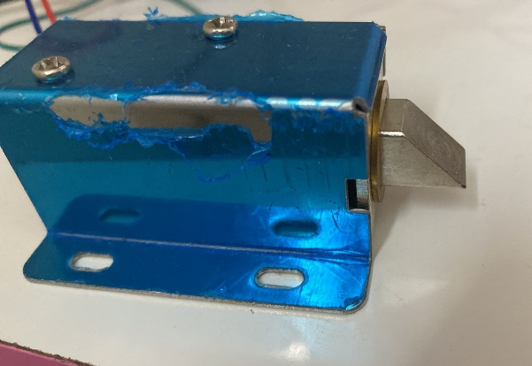

Fig 4 : Solenoid lock

**Separation of low voltage and high voltage sides of the project :**

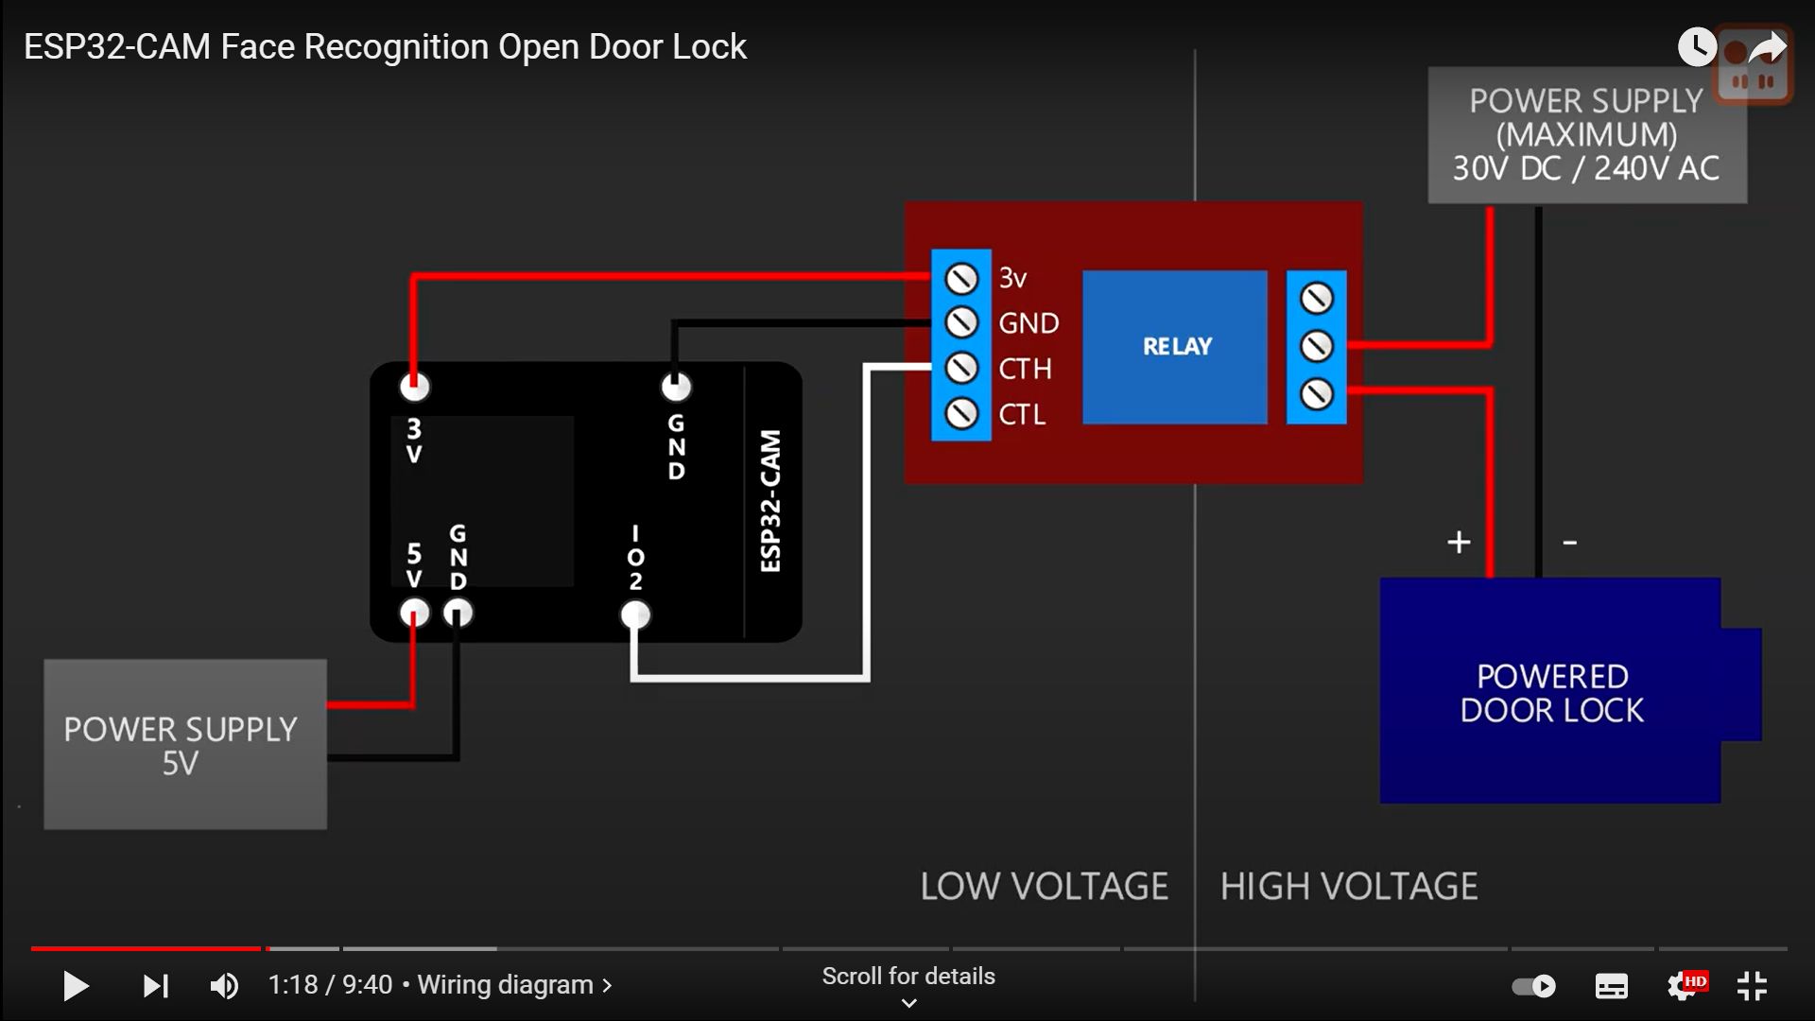

Fig 5 : Circuit diagram to demonstrate voltage separation

On the left you can see 5 volts power supply to Esp32 Cam on the right power supply to the powered door lock ,on esp32 pin2 is set high when face is recognised this causes relay to close and power to flow between power-supply and door lock.

|  |  |
| --- | --- |
| **ESP32CAM** | **Arduino UNO** |
| U0T | TX |
| U0R | RX |
| 5V | 5V |
| GND | GND |
| GPIO-0 –> GND | Reset –> GND |

Fig 6: Table to show Arduino and Esp32 connections

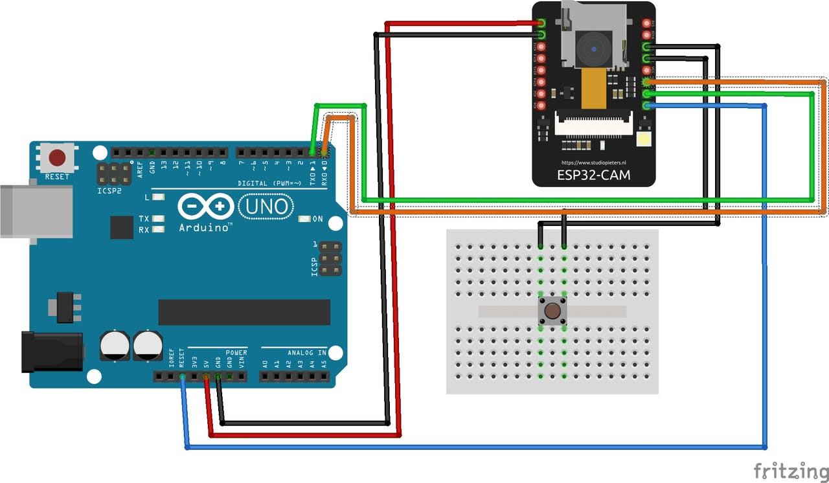

Fig 7 : Circuit diagram of Arduino and Esp32 cam

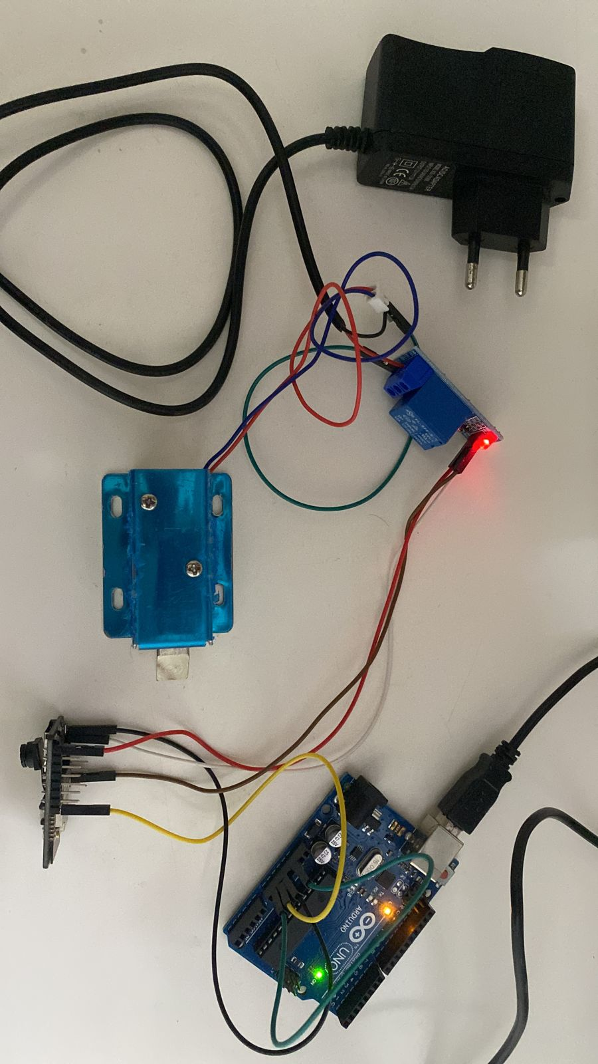

Fig 8 : Hardware Connections

In the Arduino software part update Arduino update esp32 hardware libraries to the latest versions (min of version1.0.2), and then we also need to install Arduino web-sockets library.

Normally the esp32 cam doesn’t recognize faces when the device is switched off so enrolled faces will be lost, so to allow persistent storage in arduino ide we need to add first a partition table, and setup portion scheme in arduino ide. Then the arduino generates IP address, upon entering it on the browser, the interface with video streaming is opened where we enabled the option to add faces of users for face detection access.

**CODE :**

**This link contains the code :**

[**https://drive.google.com/drive/folders/1x8VgMCjeWAXxOrwsjuvab_71y6OYlDQw?usp=sharing**](https://drive.google.com/drive/folders/1x8VgMCjeWAXxOrwsjuvab_71y6OYlDQw?usp=sharing)

**RESULTS OBTAINED**

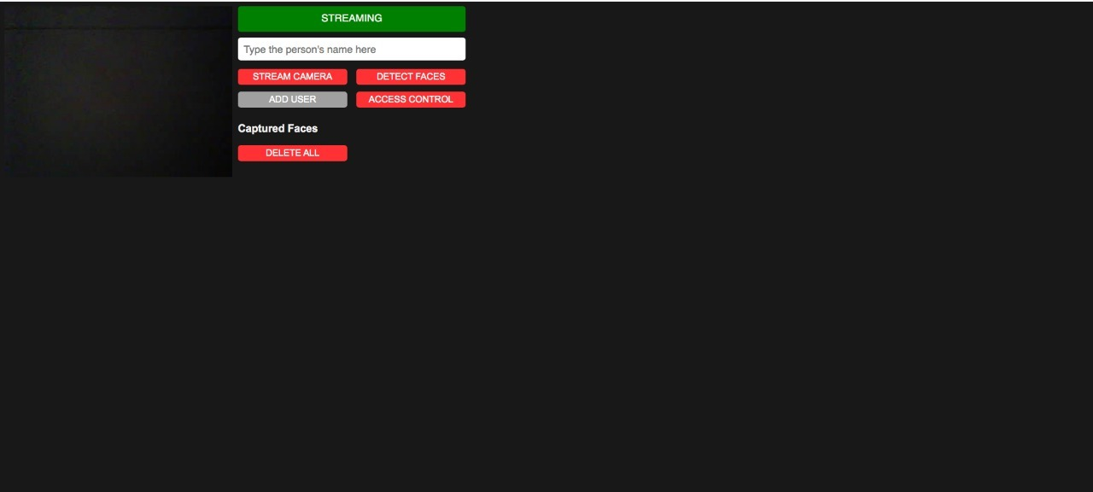

Fig 9 : Interface of Application

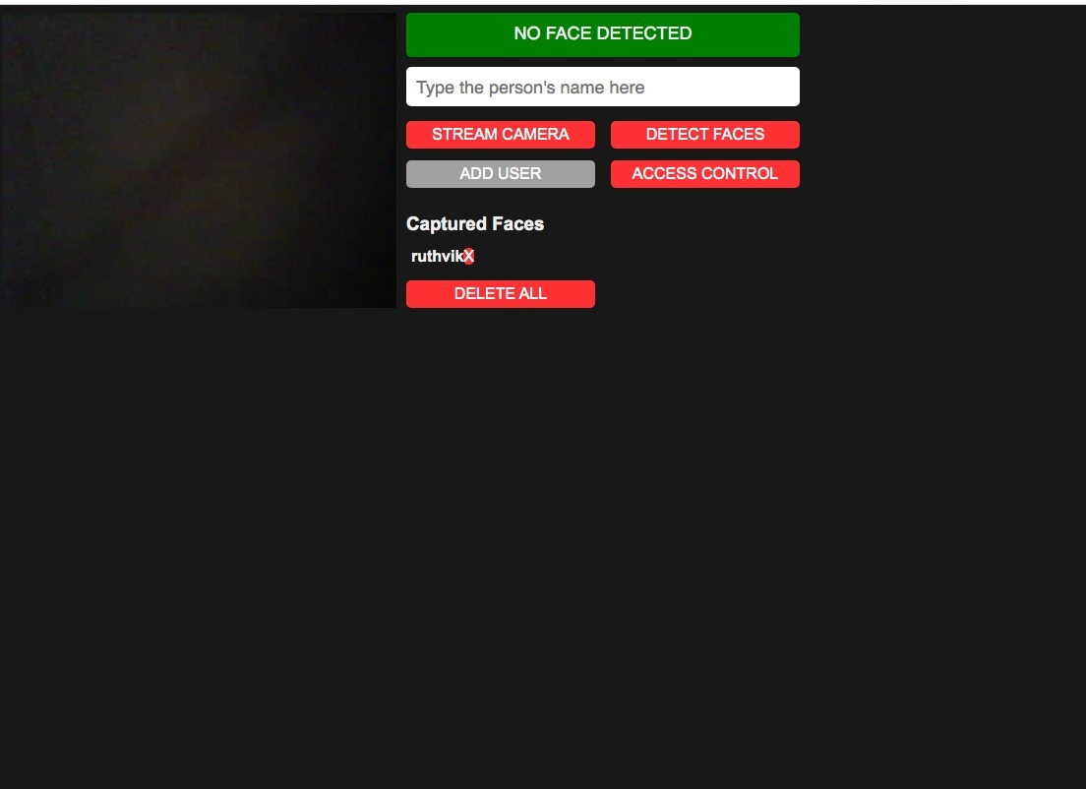

Fig 10 : Enrolling Faces in application

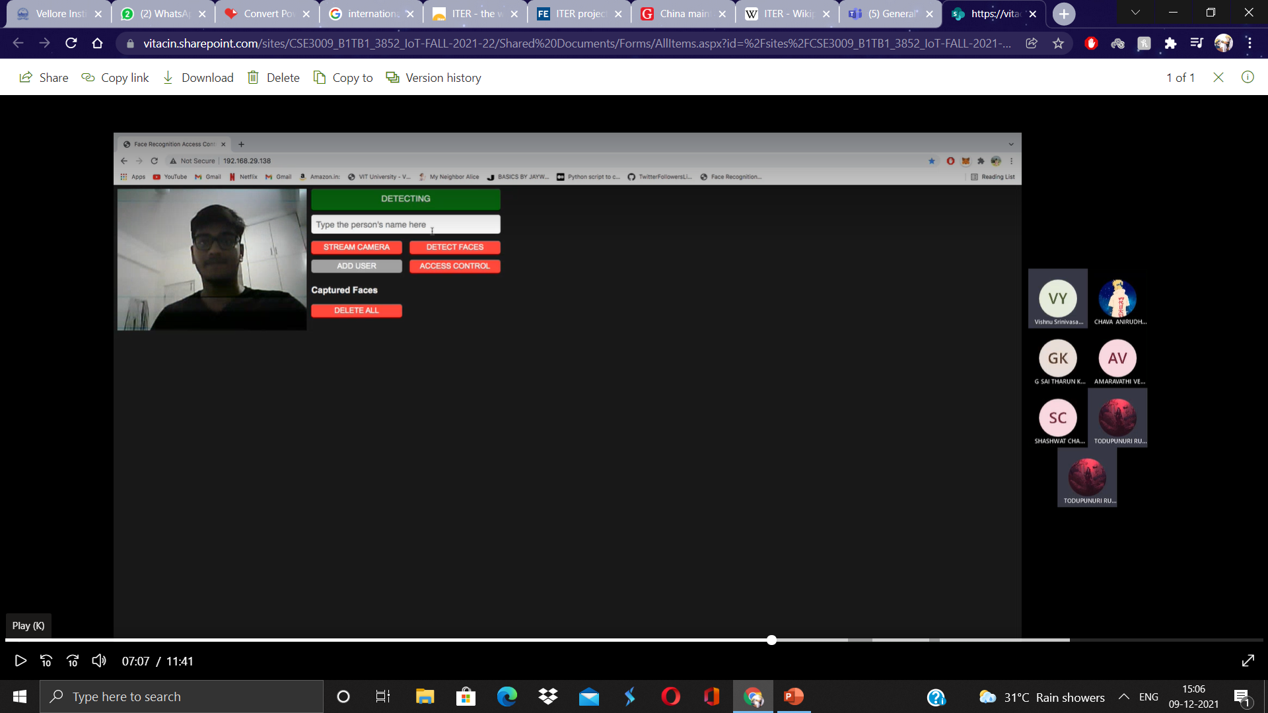

Fig 11 : Capturing face to unlock

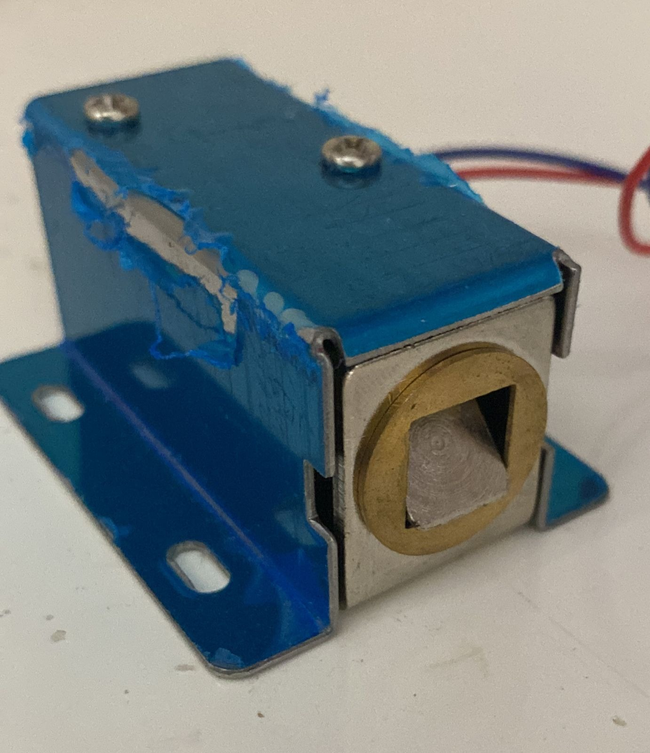

Fig 12 : Solenoid lock opened after Face detection

**CONCLUSION**

We successfully designed an IoT-based door latch control by face detection using the ESP32 Cam to monitor the status of the door to automate the door unlocking there by eliminating the usage of physical key as well as enabling the authentication form of security to unlock the door by only users whose faces are registered. we can add multiple faces in the esp32cam face detection automatic door lock. If it detects any enrolled face, the door will unlock automatically the hardware contains esp32 cam which is low power consumption module and this presented door latch control system is inexpensive to implement.

This concept as future scope can be expanded to many industries where the user requires some kind of lock and key mechanism. For example, motor vehicles like cars and bike, safe unlock and much more, this could also be expanded to make it fully functional for the beneficiary of the visually impaired people who cannot use ordinary key door lock system.

**REFERENCES**

[1] M. Jeste, P. Gokhale, S. Tare, Y. Chougule and A. Chaudhari, "Two-point security system for doors/lockers using Machine learning and Internet of Things," 2020 Fourth International Conference on Inventive Systems and Control (ICISC), 2020, pp. 740-744, doi: 10.1109/ICISC47916.2020.9171080.

[2] R. Mishra, A. Ransingh, M. K. Behera and S. Chakravarty, "Convolutional Neural Network Based Smart Door Lock System," 2020 IEEE India Council International Subsections Conference (INDISCON), 2020, pp. 151-156, doi: 10.1109/INDISCON50162.2020.00041

[3] Nag, J. N. Nikhilendra and M. Kalmath, "IOT Based Door Access Control Using Face Recognition," 2018 3rd International Conference for Convergence in Technology (I2CT), 2018, pp. 1-3, doi: 10.1109/I2CT.2018.8529749.

[4] F. L. Barsha et al., "An IoT based Automated Door Accessing System for Visually Impaired People," 2019 IEEE International WIE Conference on Electrical and Computer Engineering (WIECON-ECE), 2019, pp. 1-4, doi: 10.1109/WIECON-ECE48653.2019.9019945

[5] Patil, A.V., Prakash, S., Akshay, K., Mahadevas, W., Patgar, C. and Sharath, K.A.J. (2018). Android Based Smart Door Locking System. International Journal of Engineering Research and Technology. 6(13):1-4.

[6] Nayana, R. and Shashidhar, R. (2019). “Smart Door Lock System”, International Journal for Modern Trends in Science and Technology, 5(02),36- 38.